Adobe Experience Platform

Data Pipeline

# Lab Overview

Ingest Stores data into AEP in batch mode using Data Landing Zone. This Lab will leverage delimited data on Landing Zone and ML Recommendations to map most of the source data. This job will be scheduled to run every 15 minutes.

This lab will introduce you to the basic data ingestion process.

**Expected time: 20 minutes**

# Learning Objectives

What should you walk away with after taking this Lab?

* Understand the basic data ingestion process
* Use Data Landing Zone as a source
* Use Data Prep to Map the non-XDM data to XDM
* Scheduling batch workflows

# Lab Tasks

## Select source data

Go to Adobe Experience Platform à **Sources** à **Catalog**. In the **Cloud Storage** connectors, click **Setup** / **Add Data** in the **Data Landing Zone** card.

|  |  |
| --- | --- |
| Tip | If at least one connection exists for that source, you will see “**Add data**” as the default action. If no connections exist for that source, you will see “**Setup**” as the default action. |

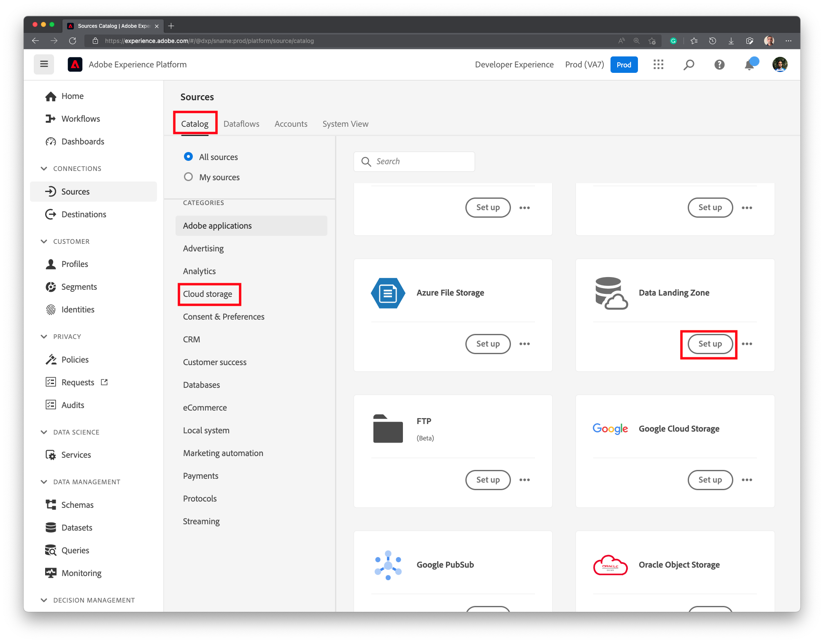

In the next screen, navigate to **project** ⟶ **PIPELINE** and select the **Lab_Lookup_Store.csv**. On the right hand side, choose Data format to be **Delimited**. Preview should load automatically. Click **Next**.

## Define the target dataset

In the **Dataflow detail** screen, choose the **Existing dataset** dep: Lookup Store. Turn on **Error Diagnostics** (default is ON), and **Enable Partial Ingestion**. Set the Data flow name as Dataflow – Lookup – Store and click **Next**.

|  |  |
| --- | --- |
| Tip | When Partial Ingestion is enabled, Error diagnostics are automatically enabled and hence the toggle box will disappear. |

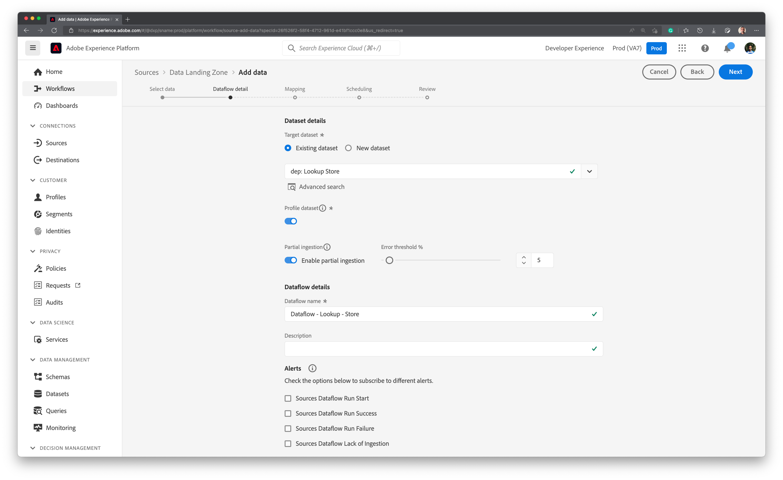

## Data Prep / Transformation

Data Prep (Mapping) step will load. The ML Recommendation Service will pre-populate the mappings for you. Please review and ensure the mappings are as follows. If all mappings look good, click **Next**.

|  |  |
| --- | --- |
| Tip | To change a mapping, click on the arrow next to the source field, or on the target field name respectively. |

## Schedule

The **Scheduling** screen will load. Change the **Frequency** to **Day** and set the **Interval** as **7**. Leave the **Backfill** toggle turned ON. This will schedule the Dataflow to run once every 7 days.

|  |  |
| --- | --- |
| WARNING | Do not set the Frequency to Once. Currently One-time ingestion flows cannot be edited. |

|  |  |
| --- | --- |
| WARNING | Schedule times are in UTC. Not your local time. |

When the **Review** screen appears, click **Finish**.

It takes few minutes to create the Dataflow. Once Dataflow is created, you will see the following screenshot. Notice that Last Dataflow Run Status indicates **No runs**. First run will kick off approximately in 15 minutes.

## Check scheduled execution

After 15 minutes, the following will appear. Notice the **Last Dataflow Run Status** and **Last Dataflow Run Date**.

Click on the Dataflow name to get a list of Dataflow Runs. 100 Records should be ingested.

Click on the Dataflow Run Start time to see error diagnostic details.

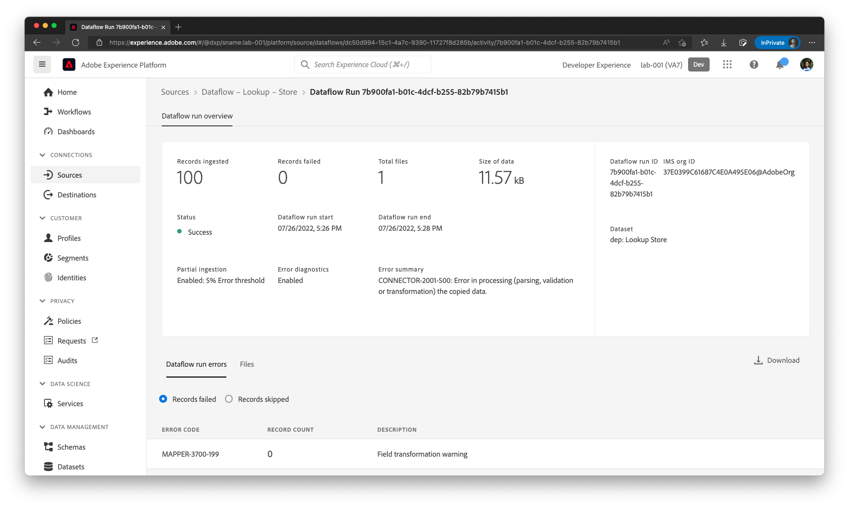

|  |  |
| --- | --- |
| NOTE | Ignore the Error code being generated. Error handling and debugging will be discussed in a subsequent lab |

## Verify the data

In the Left Nav bar, Go to **Datasets** in Platform and click on **dep: Lookup Store**

Click on the **Preview Dataset**

Data is loaded and displayed. Expand the XDM tree on the right to see child attributes.

|  |  |
| --- | --- |
| TIP | When you click on a node such as _**dxp** 🡪 **address**, the right hand side will update to show only attributes within the selected parent node (**address** in this example). To see all attributes click on the master node (**dep: Lookup Store** in this example). |

